Cirencester AC Club Coaching Survey Results

Introduction

The on-line club coaching survey was issued on 6th September and ran to 11th October. There were 40 replies (including the author’s to bring it up to 40), which is over 20% of Club members. The survey was split into a demographics type section, a club priorities section, a coaching priorities section and a box for free text comments.

Demographics
The survey respondents were asked for their gender and age (decade). The results are were:

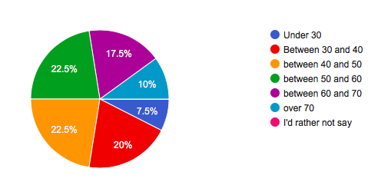

So survey is representative of Club membership by age.

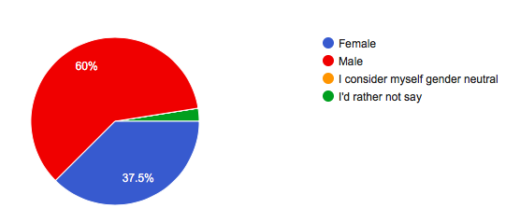
Survey is also representative based on gender.

Club Priorities

Due to an error in the way this question was set up, the analysis has been more difficult to do, but the ranking was:
- coached training sessions (>80% rated this their first choice)
- regular running groups, e.g. Monday, Thursday and Sunday (between 25 and 30% rated this first)
- Cirencester AC races, e.g. Summer Sizzler, Chedworth 10 (25%)
- teams in competitions, either league or one-off races (between 15 and 20%)
- communications through various media (15%)
- awards for achievements and contribution (15%)
- social events for the members, e.g. curry night
- club championships
- support to charities

Details as follows:
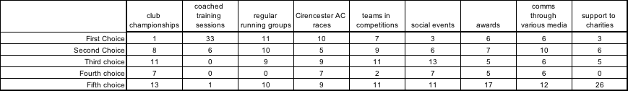

There were some subtle differences in priorities when the age groups were examined, e.g. social events are more important to the youngest and older members, with the 30 to 50 age group less enthusiastic. Also, the communications via various media was least important to those most likely to have been brought up with it, and more important to the older members of the club.

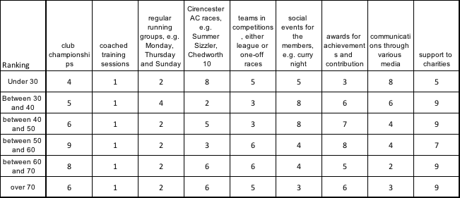

Gender results were also similar, with the only significant difference being in the priority place on the regular weekly runs:

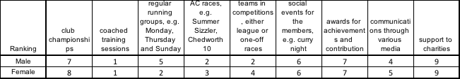

Coaching Priorities

Overall the priorities were assessed by making a statement and asking the member whether they agreed strongly, agreed, neither agreed or disagreed, disagreed, or disagreed strongly.
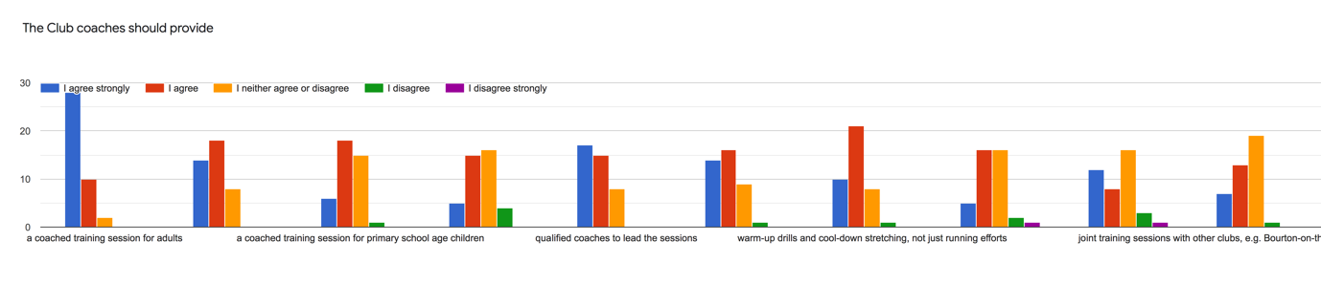

Then points were given for these rankings as 2,1,0,-1,-2. The scores for each attribute were then summed and ranked as in the following table:

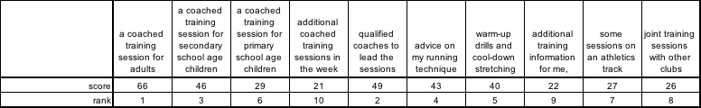

The results were then analysed by Running Group: Fast, Middle and Improvers Groups:

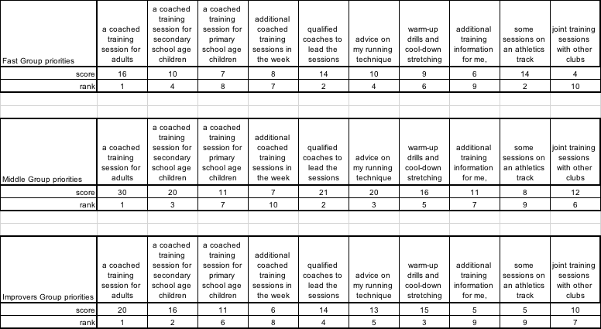

Most scores and rankings were similar for the Groups but the Fast Group desired some track sessions.

Free text comments:

In response to : “Do you have any issues, ideas or comments that you would like to raise?”

- The training load needs to meet the expectations of the faster runners
- The question on what the club should provide is confusing.
- If we had more volunteers come forward we could do so much more!
- If you want to understand the membership ask the right questions, before you do, why not explain the actions you will take and the transparency you will show. The club is fragmented, lost and without direction.
- Like cross country
- Think the club is marvellous with devoted group of volunteers and coaches
- There is a big difference in my enthusiasm for summer sessions on the track and winter sessions in street lights around the town - it is hard to find the motivation for these when one can run in day light much nearer home.
- I always did enjoy joint sessions with Bourton and would like to have them again
- Combine hills into some sessions
- I think all the coaches hold excellent training sessions which cater for all abilities. Thank you and well done
- I also compete in Aquathlons (Swimming and running). I think CAC is great!
- Maybe advice on strength fitness and other exercises to help other than just running.
- The priority question was tricky. Seemed to require answer to all lines. Essentially I am currently competitive, keen to learn from others, and proud to wear club colours when I race. As I get older I anticipate the social side will become more important.
- I’d like to take this opportunity to thank everyone who has a hand in running and organising the club, I’ve been a member for about 3 years and I’m really impressed with how friendly and organised our club is. 😀
- Sessions with experts on nutrition etc would be amazing - perhaps we could organise a virtual webinar series somehow?
- Where I answered ‘I agree’ I was indicating something I think would be nice to have.
- Advice on injuries via a specific q and a group might be a good idea?
- For a club of our size I feel we provide a good balance of coaching and running opportunities for our members - I am not sure we need to change a great deal.
- Many thanks. Haven’t run for a while but hoping to take part in the winter sessions

